Kathmandu University
Department of Computer Science and Engineering
Dhulikhel, Kavre



A Project Report
on
“KUConnect”

[Code No: COMP 206]
(For partial fulfillment of II Year/ I Semester in Computer Engineering)

Submitted by
Shriharsh Acharya (01)
Rochak Adhikari (03)
Suyog Basnet (05)
Aditya Pokharel (32)
Nerish Shrestha (51)

Submitted to
Mr. Suman Shrestha
Department of Computer Science and Engineering

Submission Date: 2025/03/09
Bona fide Certificate

This project work on
“KUConnect”
is the bona fide work of
“Shriharsh Acharya” (01)
“Rochak Adhikari” (03)
“Suyog Basnet” (05)
“Aditya Pokharel” (32)
“Nerish Shrestha” (51)
who carried out the project work under my supervision.

Project Supervisor

________________________
Er. Subhadra Joshi
Lecturer
Department of Computer Science and Engineering
Date: 2025/03/09

Acknowledgement
We would like to express our sincere gratitude to our Project Supervisor, for her unwavering support, insightful guidance, and encouragement throughout our project. Her expertise and valuable feedback have been instrumental in helping us navigate challenges and refine our work to achieve the best possible outcome.
We are also deeply grateful to the Department of Computer Science and Engineering (DOCSE) project community for giving us the opportunity to undertake this endeavor. Working on our social media web application has been an enriching experience, allowing us to explore modern development frameworks, design intuitive user interfaces, and implement robust backend solutions. The project has not only strengthened our technical proficiency but has also deepened our understanding of system architecture and real-world application development.
This journey has been an invaluable learning experience, helping us grow both as developers and as a team. We sincerely appreciate the support, resources, and guidance that have contributed to making this project a success.

Abstract
The growth of internet users in this digital world has made it necessary for universities to adapt with social media platforms for better and effective communication. KUConnect is a university-based social media web application which is to be developed with the ambition of prioritizing academic updates and interaction among the faculties and students through notices, public posts and discussions. The goal of KUConnect is to create a university focused online community with effective exclusion of external contents. The combination of React and Tailwind CSS has been utilized to create a modern and responsive frontend of the web application whereas Express.js and MongoDB are responsible for backend development which provides a powerful yet flexible environment. It is expected to provide a user-friendly web application that will increase the student connectivity, simplify event discovery and centralize university news. In conclusion, the web application attempts to bridge the gap in communication at university through technology.
Keywords: Social Media, Web Application, React, Tailwind CSS, Frontend, Express.js, MongoDB, Backend

Table of Contents
Acknowledgement ii
Abstract iii
List of Figures v
Acronyms/Abbreviations vi
Chapter 1 Introduction 1
1.1 Background 1
1.2 Objectives 2
1.3 Motivation and Significance 2
Chapter 2 Related Works 3
2.1 Reddit 3
2.2 Slack 3
Chapter 3 Design and Implementation 5
3.1 System Requirement Specifications 11
3.1.1 Software specifications 11
3.1.2 Hardware specifications 11
Chapter 4 Discussion on the achievements 12
4.1 Features 12
Chapter 5 Conclusion and Recommendation 14
5.1 Limitations 14
5.2 Future Enhancement 15
References 16
APPENDIX 17

List of Figures
Figure 2.1.1: Discussion and Content Sharing in Reddit (https://reddit.com) 3
Figure 2.2.1: Communication Features in Slack (https://slack.com) 4
Figure 3.1: Main System Flowchart 6
Figure 3.2: User Navigation Flowchart - Home and Related Pages 7
Figure 3.3: Communication Flowchart - Friends and Messages 8
Figure 3.4: Account Management Flowchart - Settings Page 9
Figure 3.5: Use Case Diagram 10
Figure i: Gantt Chart 17
Figure ii: Home Page 17
Figure iii: Messaging Section 18
Figure iv: Friends Section 18
Figure v: Notifications 19
Figure vi: Saved Posts 19
Figure vii: My Profile Section 20
Figure viii: User Profile Section 20
Figure ix: Settings Section 21
Figure x: Search Section 21

Acronyms/Abbreviations
CSS = Cascading Style Sheet
DB = Database
GB = Gigabyte
GHz = GigaHertz
JS = JavaScript
KU = Kathmandu University
OS = Operating System
RAM = Random Access Memory
UI = User Interface
WYSIWYG = What You See Is What You Get

Introduction

Background
With the increasing power of digital technology in educational institutions, universities all over the world are now adopting social media-like platforms for better connections, active participation, and effective information distribution. (Ndung'u, Vertinsky, & Onyango, 2023) Universities have now begun to adopt technologies such as Microsoft Teams, Slack, and Campuswire in order to let their students, faculty, and staff come together, provide personal updates, and keep the sense of community alive online. (Johnson, 2020) It is in this respect that modern universities are able to create online communities that interlink academic and social needs of the students, thus providing them with a sense of belonging-even virtually.
Despite such functionalities, existing solutions face certain drawbacks when tailored for educational settings. General-purpose social networking sites, such as Facebook and Instagram, are immensely interactive but usually do not meet the specific needs of communication which an academic institution demands. (Astleitner & Sarah, 2024) They tend to be distracting and often lack adequate privacy settings that meet academic interactions, hence filtering or prioritizing the content about university affairs is improbable. For this reason, traditional social media platforms cannot work effectively for most universities in engaging their students with university life.
KUConnect is proposed to address these issues by creating a university-based social media platform. It will prioritize academic updates and university-specific interactions, offering a focused environment for students and faculty to share notices, publish posts, and have topic-driven discussions where there is no external content.

Objectives
The major objectives of KUConnect are listed below:
i. To create a centralized platform for KU news, announcements, and events.
ii. To provide real-time push notifications for important updates.
iii. To enable categorized news and threaded posts for easy navigation and relevance.
iv. To foster a more engaged and connected KU community through interactive features like commenting and sharing.

Motivation and Significance
The idea behind KUConnect was inspired by the fact that the majority of KU students prefer Facebook groups to the official university website for news and events on campus. Despite being easily accessible, this reliance on social media frequently lacks structure and results in a disjointed experience. We want to close this gap by creating a KU-specific news platform with an easy-to-use interface that consolidates content in a more dependable and organized manner. With its classified news feeds, interactive features, and real-time updates, KUConnect will make it simpler for teachers and students to find pertinent information quickly. KUConnect will lessen reliance on outside social media by offering a simplified and easily navigable site designed just for KU, all the while encouraging a more involved and knowledgeable campus community.

Related Works
Some existing platforms related to our project are mentioned below:

Reddit
Reddit is an online platform that hosts communities, or "subreddits", focused on specific topics where users can post content and participate in threaded discussions. (Reddit, n.d.) With its upvoting and downvoting system, Reddit emphasizes community-driven discussions, allowing users to interact meaningfully on various topics. This structure supports long-form, topic-based discussions, which can serve as a model for creating academic and interest-focused forums within a university social media app.
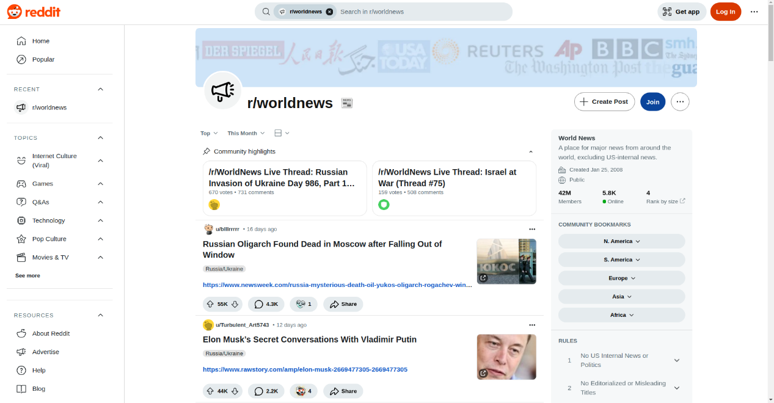
Figure 2.1.1: Discussion and Content Sharing in Reddit (https://reddit.com)

Slack
Slack is a widely used communication and collaboration platform that allows teams to stay connected in real time. (Slack, n.d.) It organizes conversations into channels, which can be dedicated to specific projects, topics, or teams, helping users keep discussions focused and organized. Channels can be public for the whole team or private for specific members. Slack also supports direct messaging for private one-on-one or small group chats, making it easy to have quick, focused conversations. Additionally, customizable notifications help users stay updated on important conversations, while the option for voice and video calls makes remote collaboration even more effective.
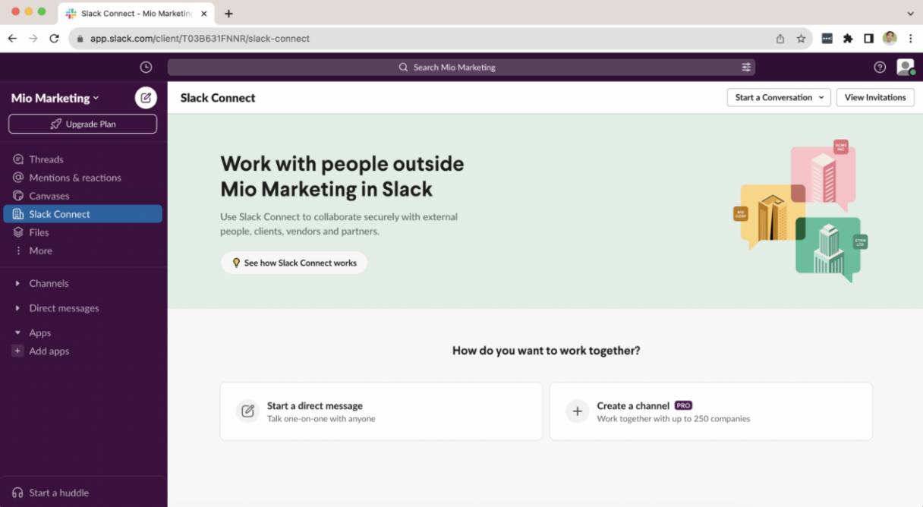
Figure 2.2.1: Communication Features in Slack (https://slack.com)

Design and Implementation
The following outline provides an overview of the sequential process and techniques used during the project:
Step 1: Project Planning
We began by organizing our project workflow, assigning tasks among team members to ensure an efficient development process.
Step 2: System Design and Architecture
After defining the project requirements, we designed the system architecture, including the DB schema, user interface layouts, and overall structure. Flowcharts and system diagrams were created to illustrate data flow and component interactions within the system.
Step 3: Development and Coding
            - Backend: The software was built using Express.js as the backend framework, with React handling the frontend development.
            - DB Implementation: The DB was implemented using Mongoose, providing an interface for managing and querying MongoDB efficiently.
            - User Interface Design: The UI was developed using React, ensuring a responsive and intuitive user experience.
- Testing and Debugging: Comprehensive testing was conducted, including unit testing, integration testing, and user acceptance testing. A continuous bug-tracking process was followed to maintain application stability.
Step 4: Documentation
A complete set of documentation was prepared, including technical documentation and user manuals. Throughout the project, regular team communication and collaboration were maintained to align with project goals and user expectations.
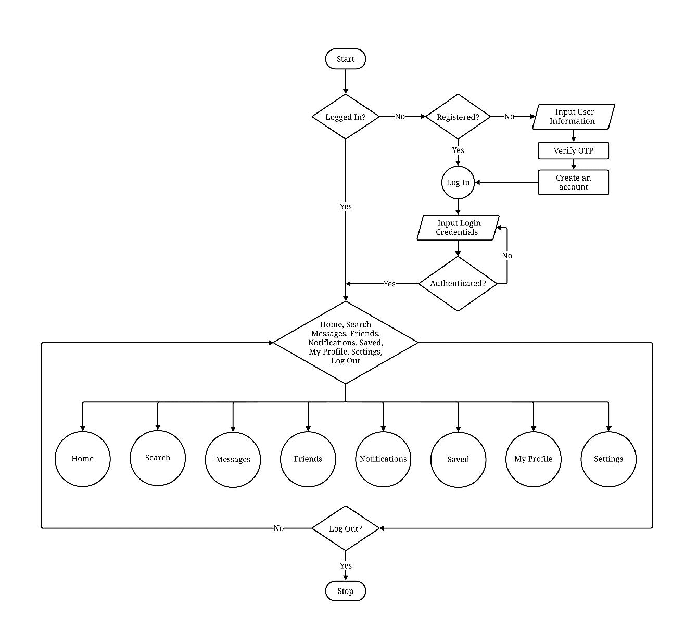
Figure 3.1: Main System Flowchart
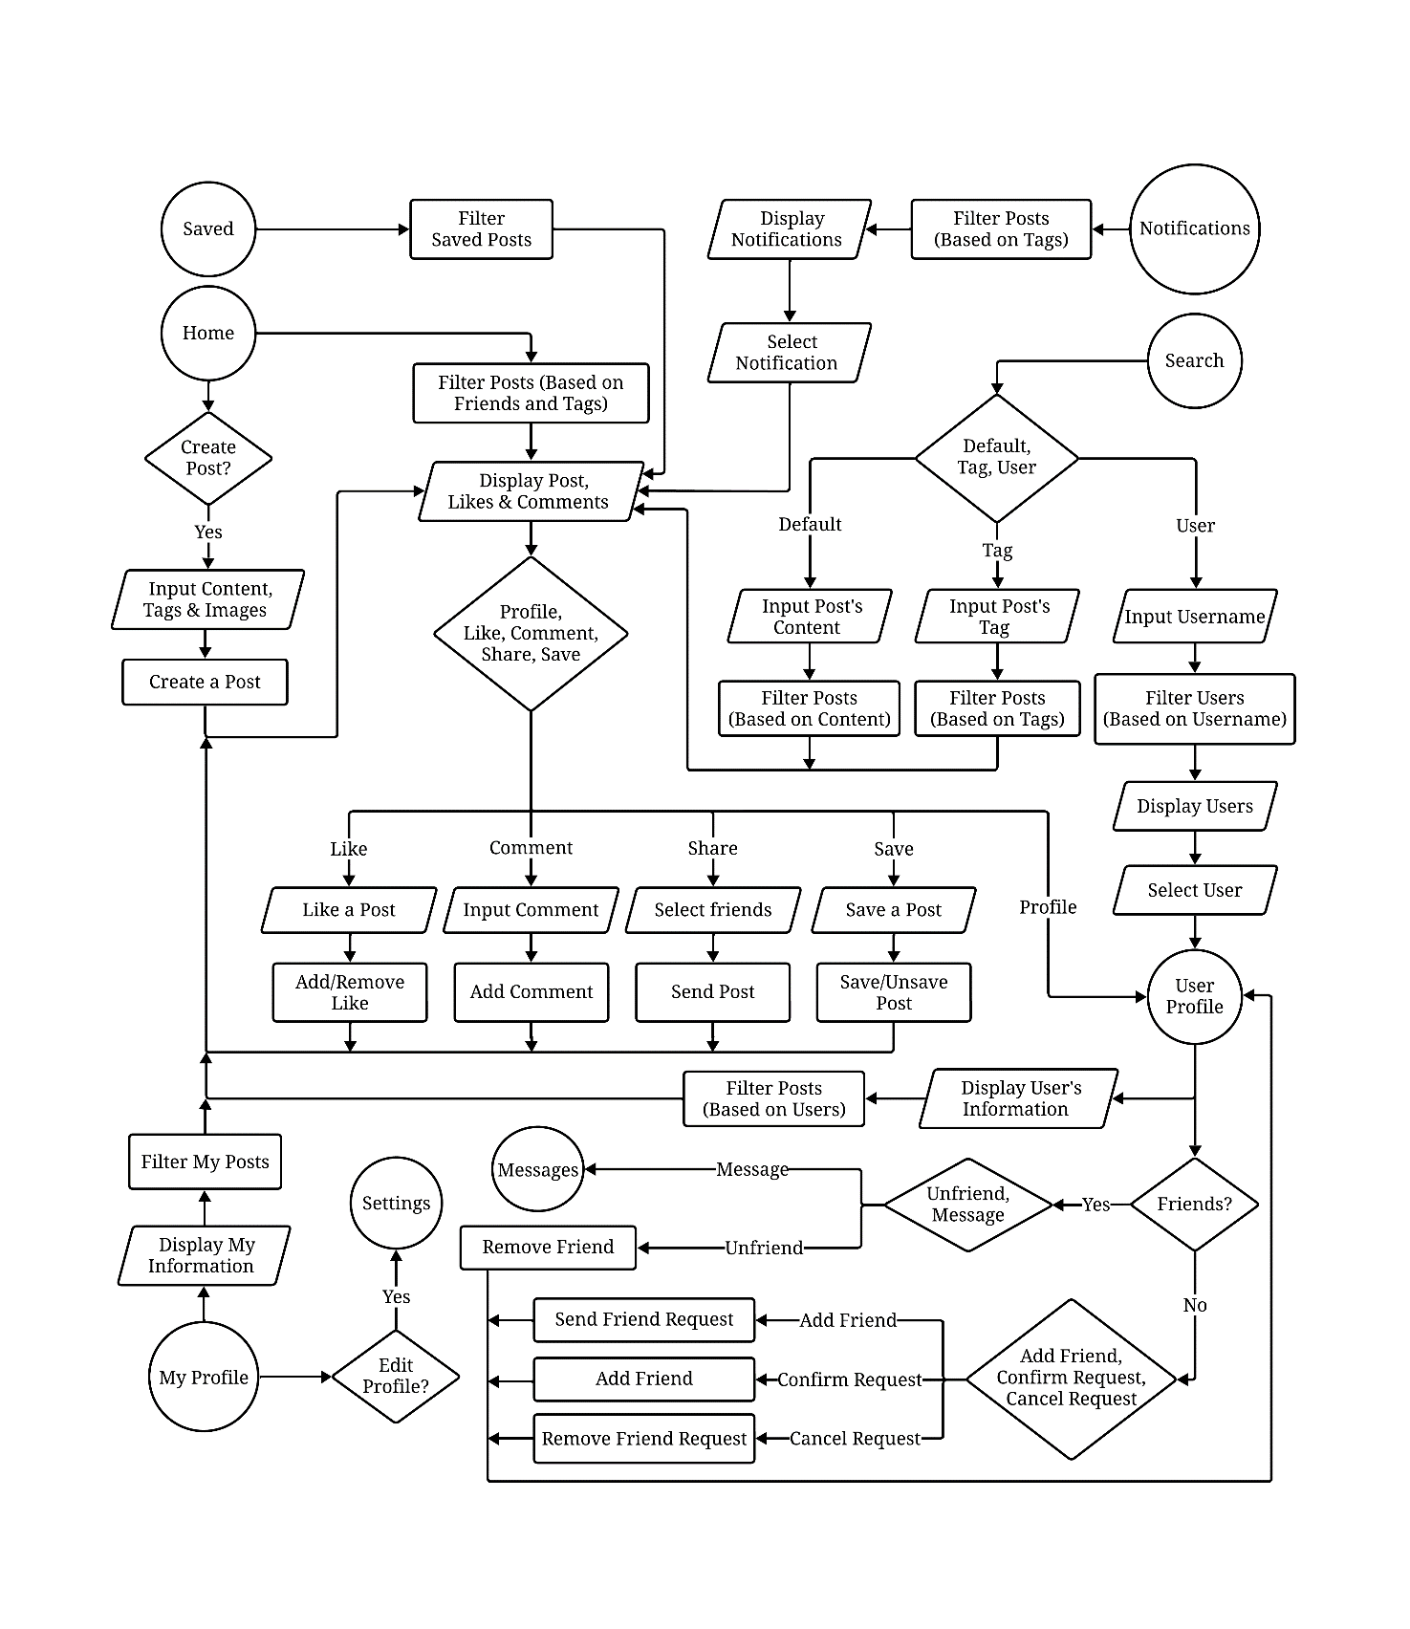
Figure 3.2: User Navigation Flowchart - Home and Related Pages
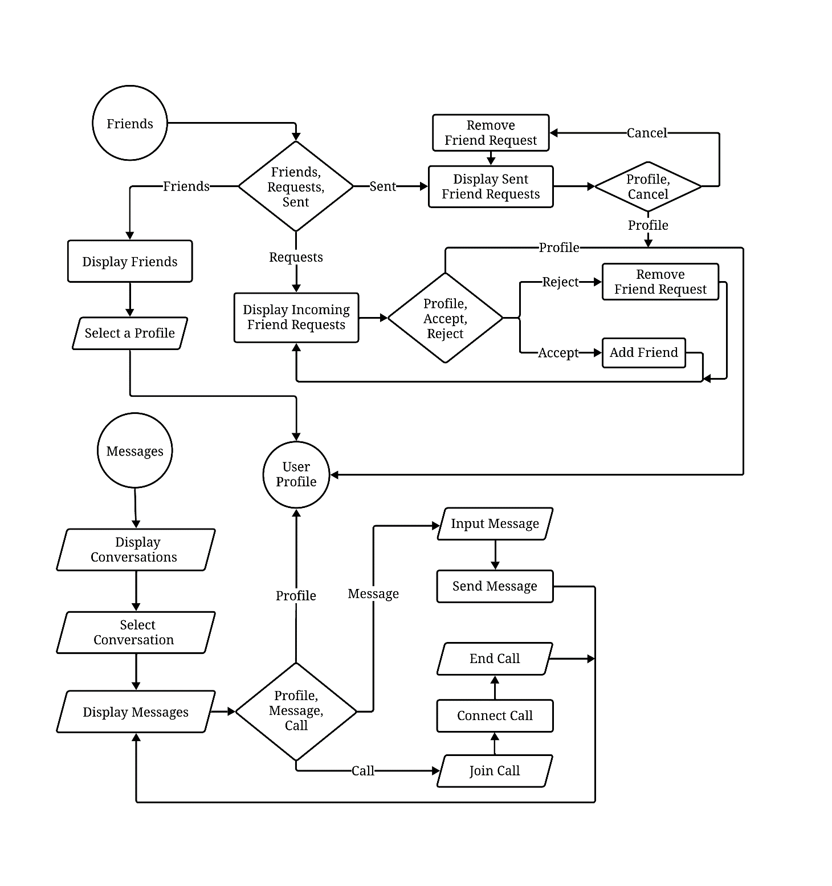
Figure 3.3: Communication Flowchart - Friends and Messages
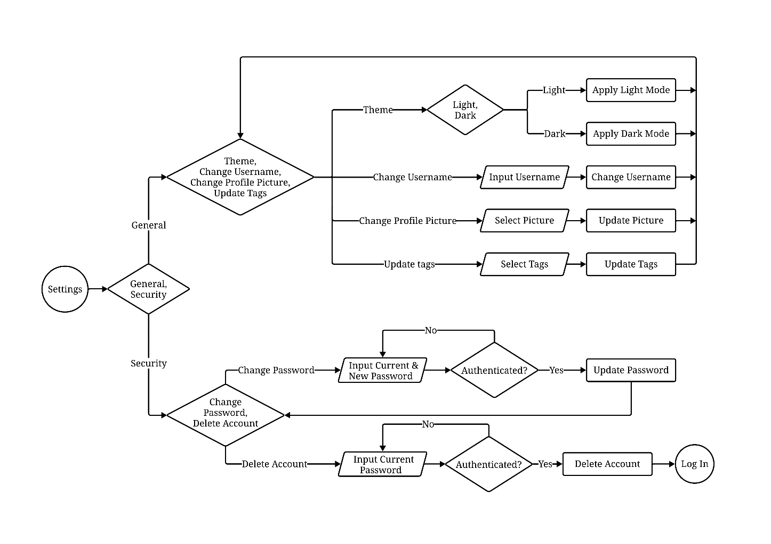
Figure 3.4: Account Management Flowchart - Settings Page
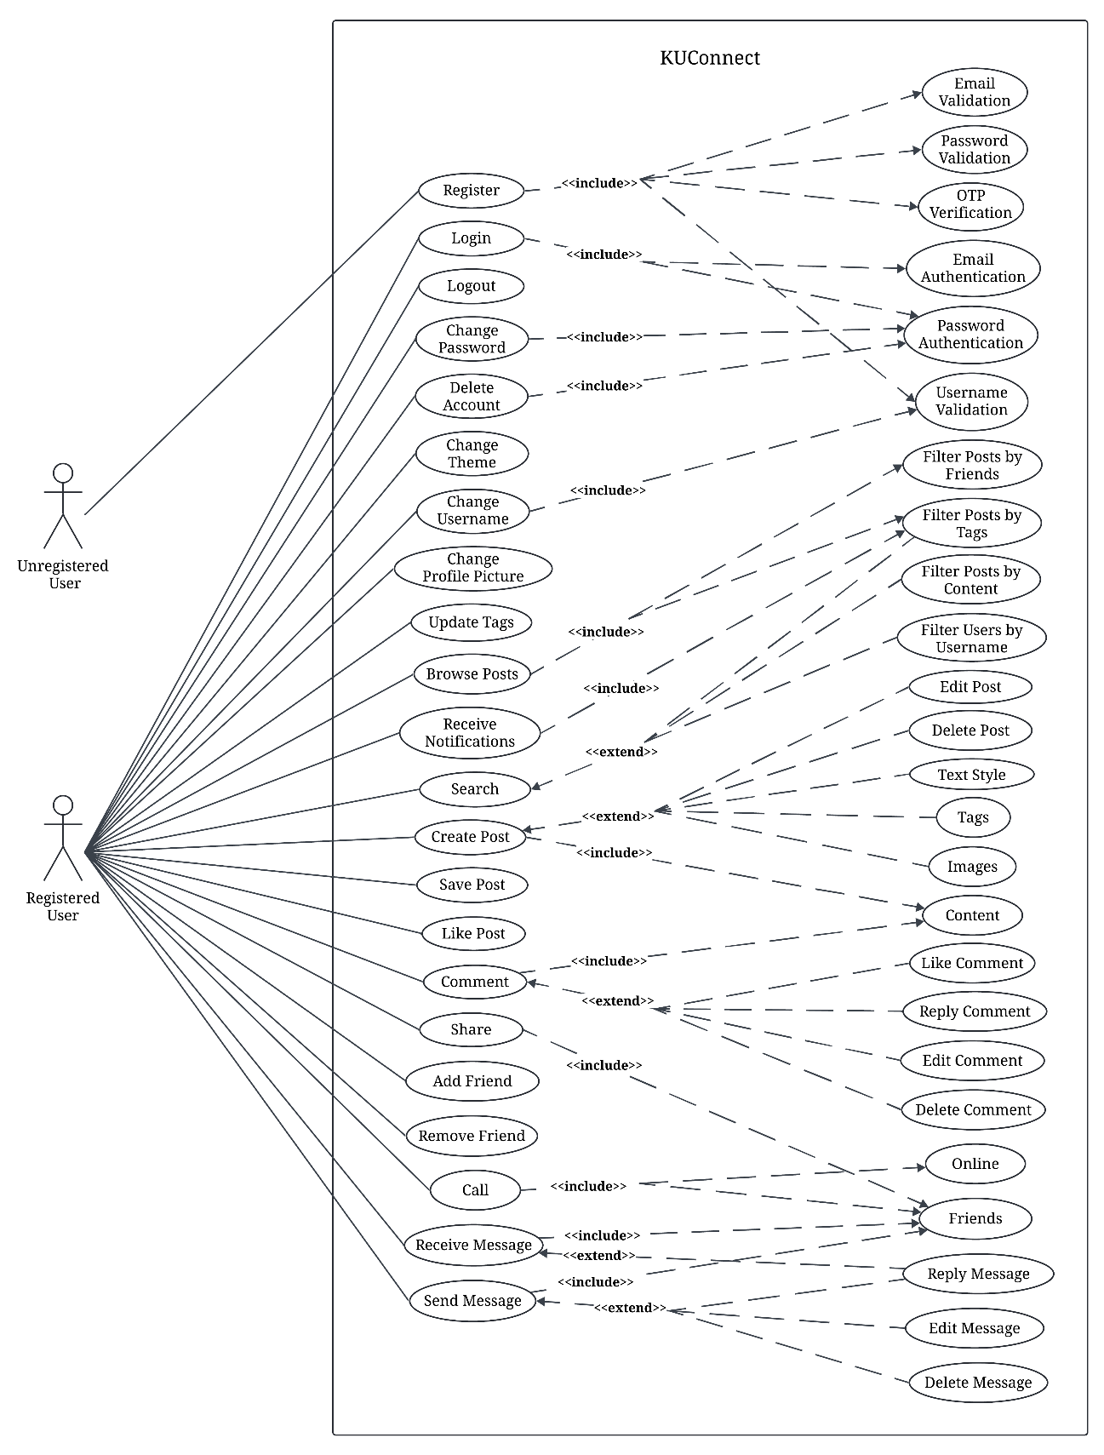
Figure 3.5: Use Case Diagram

System Requirement Specifications

Software specifications
Since this social media application for KU was developed as a web application using JavaScript, the system requirements are aligned with modern web applications built using JavaScript frameworks. The application has utilized Mongoose for DB management, React Native for the user interface, and web sockets for real-time messaging. The following are the suggested software requirements for KUConnect:
- Browser Compatibility: The application is supported on modern browsers, including Google Chrome, Firefox, Safari and Microsoft Edge.
- Operating System Compatibility: The web application works across platforms, including Windows, macOS and Linux as long as they support the compatible browsers.
- Internet Connection: A stable internet connection is required, especially for real-time messaging through web sockets.

Hardware specifications
To ensure optimal performance, the following hardware specifications are recommended. However, the application is designed to be lightweight and can function on most modern devices. The suggested hardware requirements are:
- Processor: 1.5 GHz dual-core processor or equivalent.
- Memory: 4 GB of RAM.
- Storage: 200 MB for cache and local storage.

Discussion on the achievements

Features
- Login/Registration
- Users can create an account using their email and password or sign in with existing credentials.
- Secure authentication mechanisms, such as password hashing and session/token-based authentication, ensure account security.
- Error handling and validation checks (e.g., duplicate emails, password strength) are implemented for a smooth onboarding experience.
- Create, Edit, and Delete Posts (Including Images, Embedded Videos, and Formatted Text)
- Users can create posts with rich text formatting options, including bold, italics, lists, and links.
- Support for media attachments, allowing users to upload images and embed videos directly into their posts.
- Editable posts enable users to make modifications after publishing, with an option to delete posts if necessary.
- Markdown or a WYSIWYG editor is integrated for an intuitive content creation experience.
- Instant Messaging
- Real-time messaging is implemented using WebSockets, enabling seamless conversations between users.
- Messages are stored in the DB for persistent chat history.
- Typing indicators, read receipts, and notifications enhance the messaging experience.
- A responsive chat UI ensures accessibility across different devices.
- Subscribe to Tags (Topics) You Prefer
- Users can follow specific tags or topics to tailor their content feed.
- Subscribed topics appear in a personalized feed, ensuring users stay updated on discussions that interest them.
- Notifications can be enabled for new posts under ‘followed’ tags.
- User-Friendly Interface
- The UI is designed to be clean, modern, and easy to navigate.
- Responsive design ensures a seamless experience across desktops, tablets, and mobile devices.
- Dark mode and accessibility features, such as adjustable font sizes and keyboard navigation, are incorporated for better usability.
- Functional Search Component
- A search bar allows users to find posts, tags, and users efficiently.
- Advanced filtering options, such as sorting by relevance, date, or popularity, enhance search functionality.
- Full-text search ensures accurate and fast retrieval of relevant results.

Conclusion and Recommendation
The development of KUConnect aims to address the communication gap within Kathmandu University by providing a dedicated platform for academic interactions and campus-related updates. Through features like real-time messaging, categorized posts, and a user-friendly interface, the application ensures that students and faculty members remain informed and connected. Utilizing modern technologies such as React, Tailwind CSS, Express.js and MongoDB, the project demonstrates an efficient integration of frontend and backend systems.
While the application successfully implements core functionalities such as login/registration, post creation, instant messaging, and topic subscriptions, certain limitations remain, particularly in scalability, advanced security measures, and comprehensive accessibility features. Despite these challenges, KUConnect has achieved its objective of creating a centralized and distraction-free environment for university-specific communications, ultimately fostering a more engaged campus community.

Limitations
While the KUConnect project achieved significant milestones, certain limitations remain:
- Scalability Constraints: The current architecture may face performance issues with a significantly large user base.
- Basic Security Measures: Although standard authentication is implemented, advanced security features like two-factor authentication (2FA) and end-to-end encryption are absent.
- Limited Accessibility Features: The application lacks comprehensive accessibility options for users with disabilities, such as screen reader support or voice navigation.
- Absence of a Mobile Application: While the web application is responsive, a dedicated mobile app would enhance usability and accessibility.

Future Enhancement
To improve upon the current version of KUConnect and address the identified limitations, the following recommendations are suggested:
- Enhance Security and Privacy: Implement two-factor authentication and end-to-end encryption to strengthen account and messaging security.
- Improve Scalability and Performance: Optimize backend code and use cloud services for better load handling and faster data processing.
- Develop a Dedicated Mobile Application: Create Android and iOS apps to improve accessibility and increase user engagement.
- Expand Accessibility Features: Add screen reader support, customizable text sizes, and high-contrast modes to cater to diverse users.

References
(n.d.). Retrieved January 1, 2025 from Slack: www.slack.com
(n.d.). Retrieved March 1, 2025 from Reddit: www.reddit.com
Astleitner, H., & Sarah, S. (2024). The social media use of college students: Exploring identity development, learning support, and parallel use. Sage Journals.
Johnson, L. (2020). Blog: Slack. From Slack: https://slack.com/intl/fr-fr/blog/collaboration/universities-keep-class-in-session-with-channels
Ndung'u, J., Vertinsky, I., & Onyango, J. (2023). The relationship between social media use, social media types, and job performance amongst faculty in Kenya private universities. Heliyon.

APPENDIX
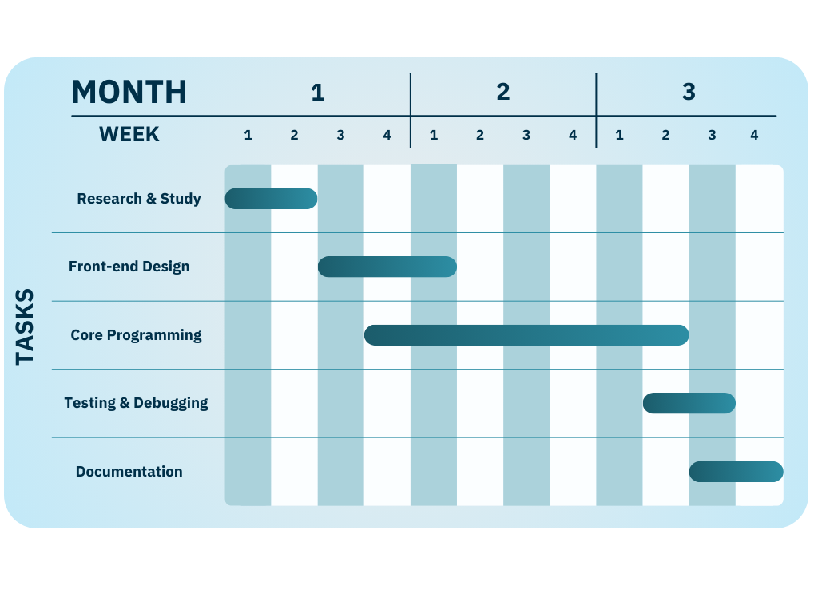
Figure i: Gantt Chart

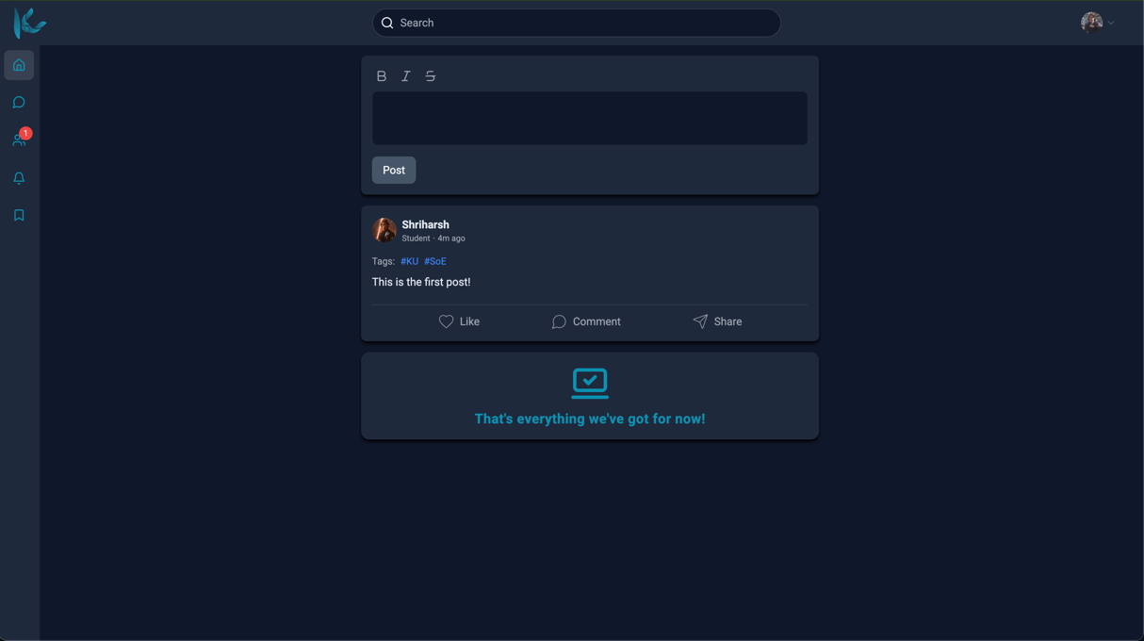
Figure ii: Home Page
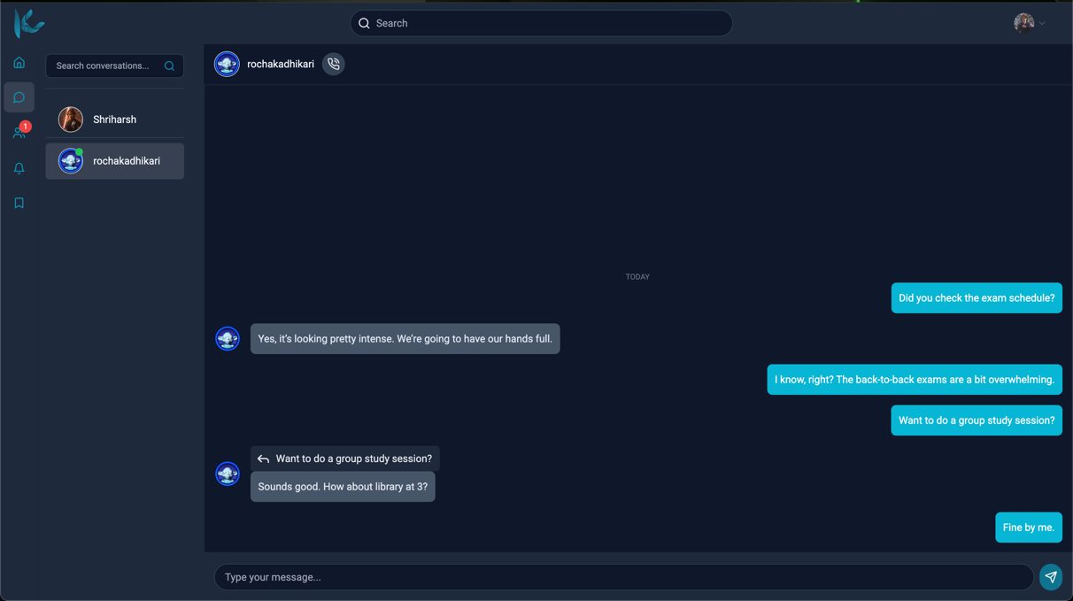
Figure iii: Messaging Section

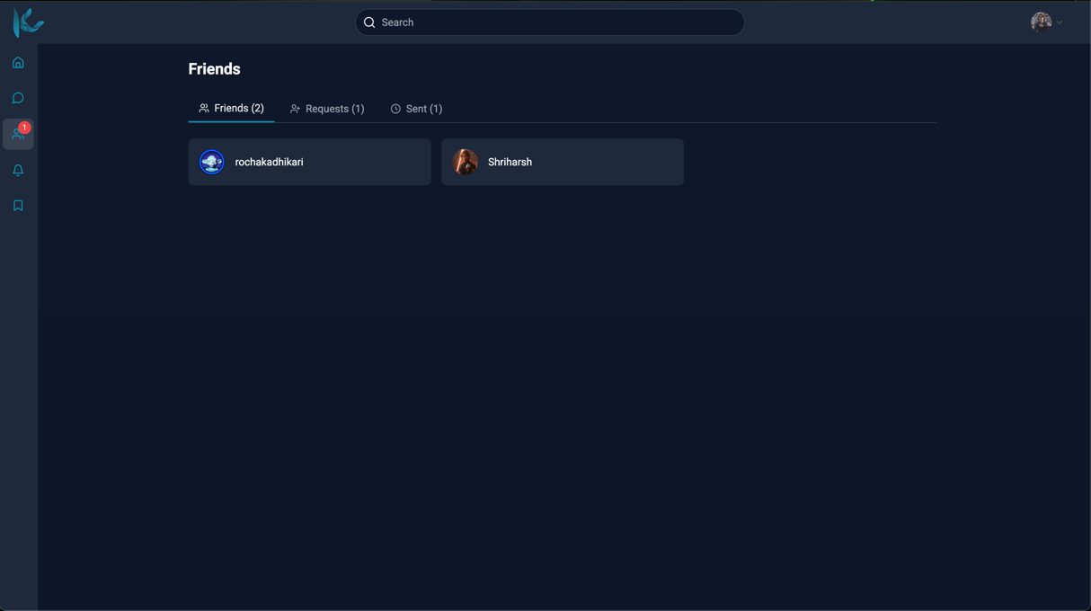
Figure iv: Friends Section

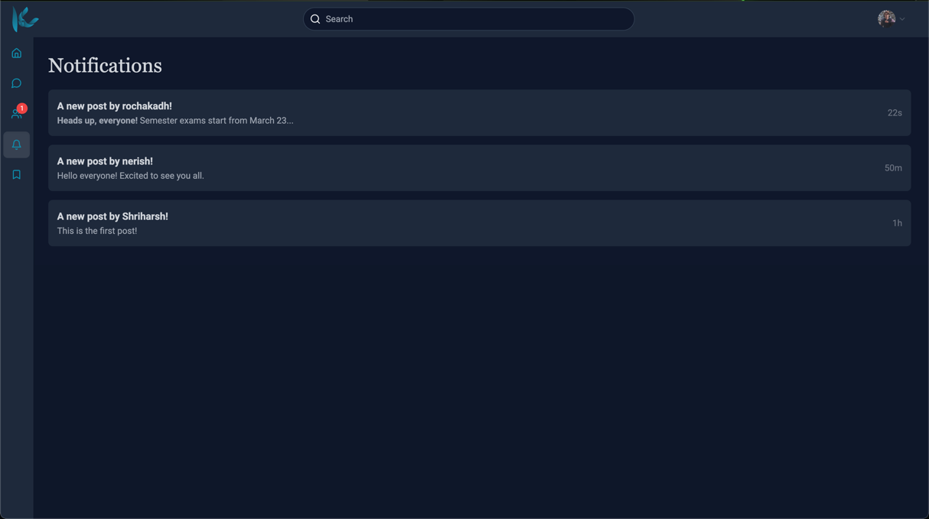
Figure v: Notifications

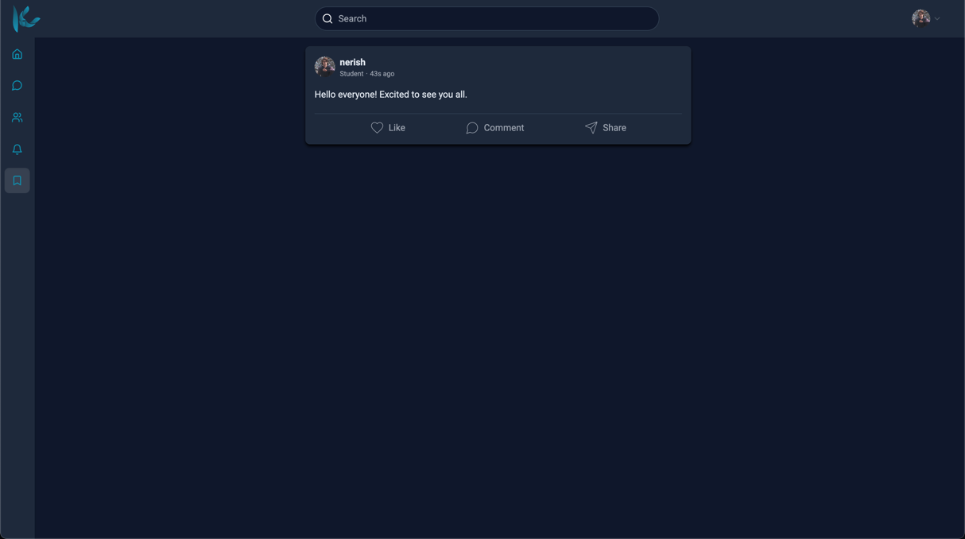
Figure vi: Saved Posts

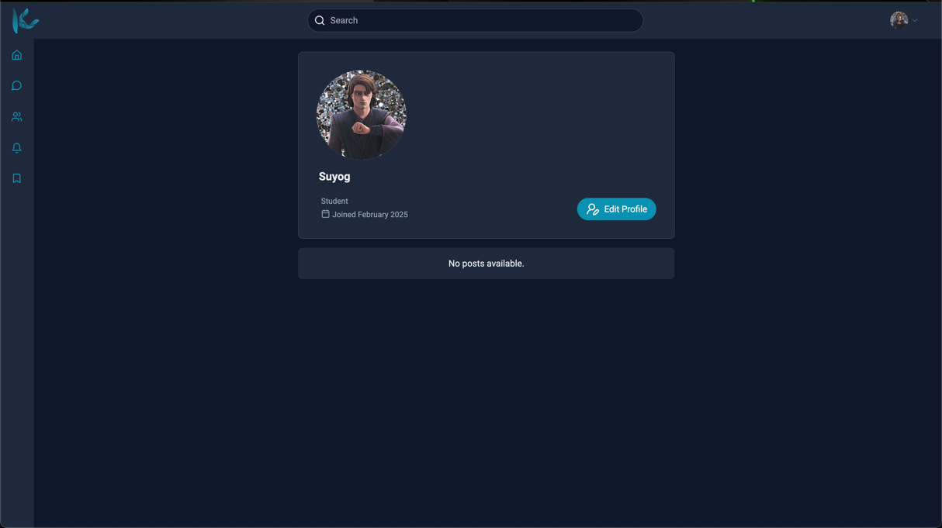
Figure vii: My Profile Section

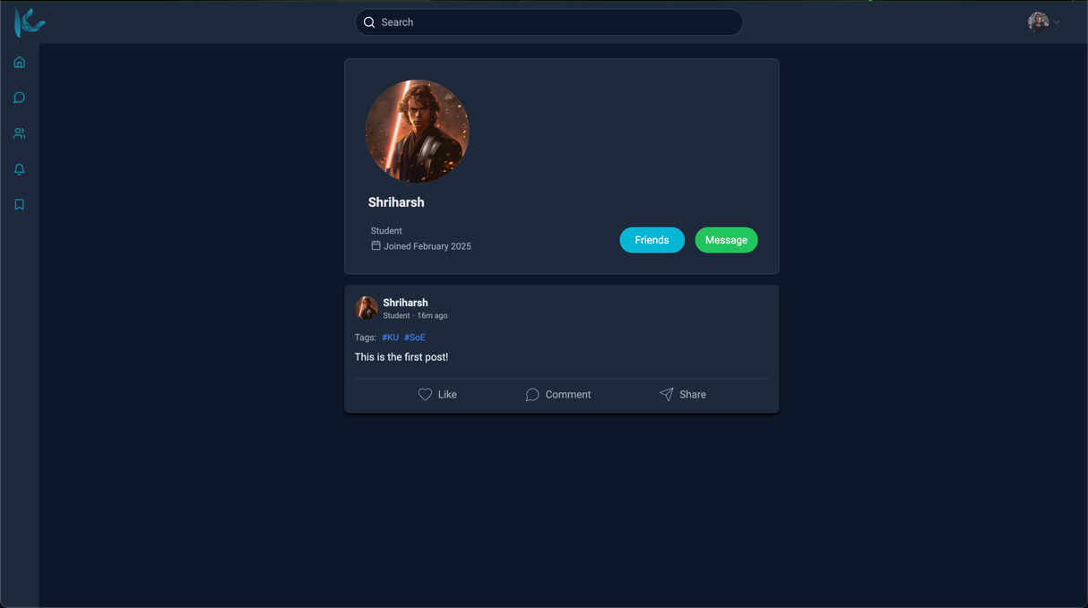
Figure viii: User Profile Section

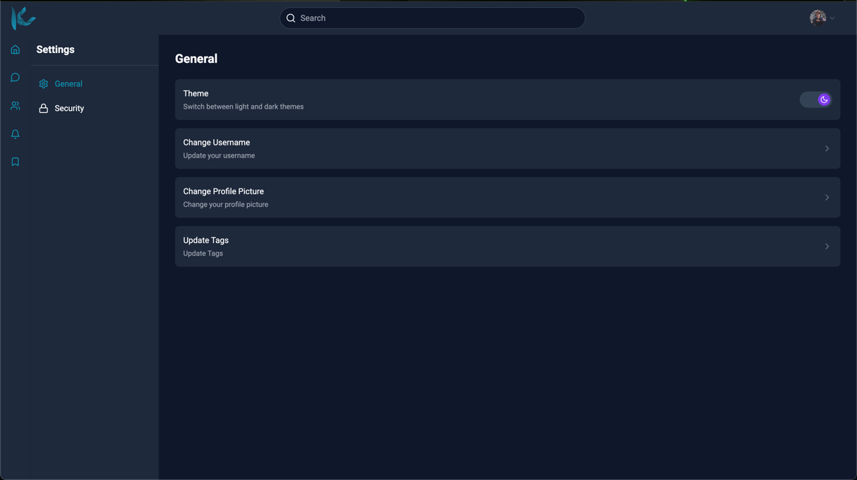
Figure ix: Settings Section

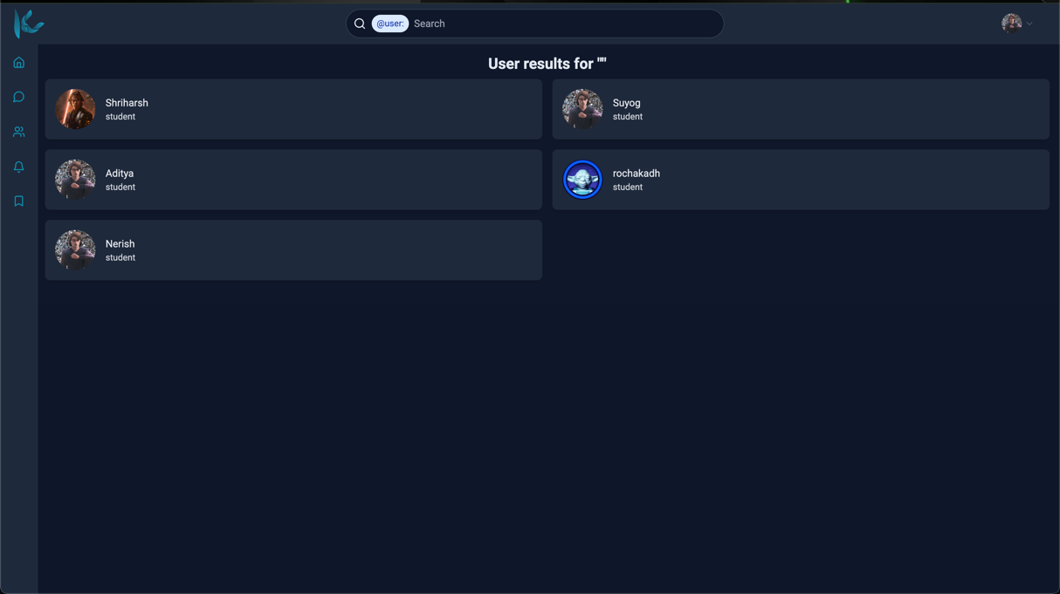
Figure x: Search Section

